|  |
| --- |
|  |
|  |

**Name**: GANTANA.BHASKARA RAO

**Batch**: 202403-01

**Capstone**: **Shopnest Power BI Capstone Project**



[This Photo](https://repositorio.konradlorenz.edu.co/micrositios/001-1527/001-1527.html) by Unknown Author is licensed under [CC BY-SA](https://creativecommons.org/licenses/by-sa/3.0/)

Let’s get started …

Question 1: Identify the rating distribution in the Shop_Nest dataset, showcasing ratings categorized as Excellent, Very Good, Good, Bad, and Very Bad, along with corresponding orders

Solution: For this question I have created a new column as Rating Category from the review score of order reviews table and rated 5 as ”Excellent” ,4 as “Very Good”, and 3 as ”Good “ ,2 as “Bad” and finally 1 as “Very bad “.

Detailed Order Analysis:

The detailed table and charts further break down the number of orders corresponding to each rating category, allowing for a deeper understanding of which products or services are underperforming. This can guide targeted improvements and strategic decisions.

|  |
| --- |
|  |

The rating distribution analysis highlights areas of strength and opportunities for improvement. Positive ratings underscore areas where the company excels, while lower ratings point out specific issues that need addressing. By focusing on enhancing aspects related to "Good", "Bad", and "Very Bad" reviews, the company can work towards increasing overall customer satisfaction and loyalty

Question 2: What are the top 10 and bottom 18 most popular product categories in the ShopNest dataset? Please list them based on the number of orders

Solution: For this I have created a new measure OrdersCount To count the number of orders per product category, create a measure in the *Order_items_dataset* table

* Add a Table or Matrix visual to your report.
* Drag the product_category_name from the *Product_categories* table into the Rows field.
* Drag the OrdersCount measure into the Values field

|  |
| --- |
|  |

**Insights:**

* **High Demand:** The top 10 categories are consistently high in orders, indicating strong customer demand. Categories 1,2,3rd places are particularly popular, suggesting they are key drivers of sales.
* **Low Demand:** The bottom 18 categories exhibit significantly lower order volumes. These categories may represent niche products or those that are less popular among customers.

Conclusion: The analysis of product categories based on order volume provides valuable insights into customer preferences and sales performance. By focusing on high-demand categories and addressing issues in less popular ones, strategic decisions can be made to enhance overall business performance and customer satisfaction.

Question 3: List the total number of active sellers by yearly and monthly

Solution: I have created a new measure to calculate the active sellers count,and also Year and Month Columns in the orders dataset based on the purchased_order_timestamp.

Visualize the Data:

* Use Line Charts or Column Charts to visualize the total number of active sellers by year and month

* ACTIVE SELLER BY YEAR

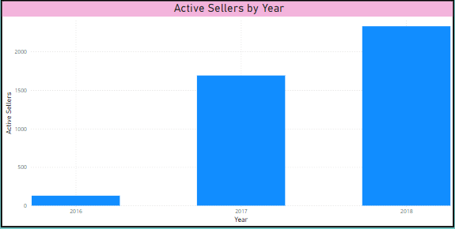

**Strategic Focus**: To maintain or increase the number of active sellers, consider focusing on strategies that boost engagement during the lower months and Year. Analyze factors contributing to higher seller activity during peak months and replicate successful strategies

* **ACTIVE SELLER BY MONTH**

|  |
| --- |
|  |

**Conclusion:** Tracking active sellers by year and month provides valuable insights into seller engagement trends. By understanding these patterns, ShopNest can optimize its seller management strategies, plan targeted promotions, and improve overall market presence

Question 4: Which payment methods are most commonly used by ShopNest customers.

**Solution**: For this I have created a measure to count the number of transactions payment method

**Visualize the Data:**

* To make the data more accessible, use a **Donut Chart** to visualize the distribution of payment methods.
* Add a **Donut Chart** to your report.
* Drag the payment_type column to the Legend (for Pie Chart) or Axis (for Bar Chart).
* Drag the Payment_Method_Count measure to the Values field

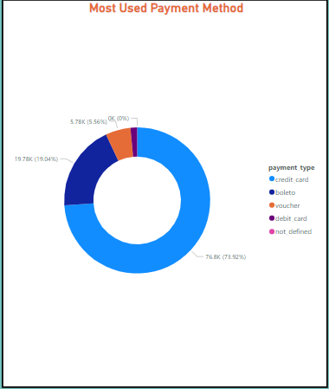

**Dominant Payment Methods:** Credit Cards and Debit Cards are the most popular payment methods among ShopNest customers, accounting for a combined 75% of transactions. This indicates a preference for electronic payments, which are often faster and more convenient for customers

**Conclusion:** The analysis of payment methods reveals clear preferences among ShopNest customers for electronic payments, particularly Credit and Debit Cards. By understanding these trends, ShopNest can tailor its payment processing strategies to enhance user experience and align with customer preferences.

Question 5: Identify the product category. wise profit margin using the formula  
Hint: (Payment value -price + Freight_value)/payment_value*100 (Rounded to two decimal points).

Solution: I have Created a new calculated column in the Order_items to compute the profit margin using the provided formula.

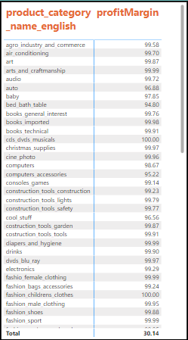

**Conclusion:** Understanding profit margins by product category allows ShopNest to make informed decisions on product management, pricing strategies, and marketing focus. By leveraging categories with higher margins and addressing issues in less profitable ones, ShopNest can enhance overall profitability and business performance.

Question 6: Determine the monthly payments made by customers using credit cards

Solution: I have Created a new measure to filter and sum the payment values where the payment method is 'Credit Card'.

**Column Chart:**

* Add a **Column Chart** to your report.
* Drag Year and Month from the Date Table to the Axis field.
* Drag the Monthly_Credit_Card_Payments measure to the Values field.
* This will display the monthly credit card payments over time

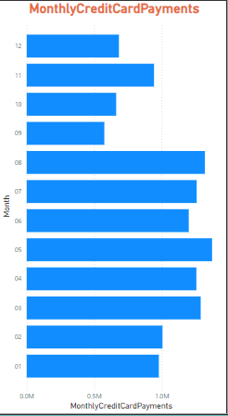

**Conclusion:** The monthly credit card payments analysis provides valuable insights into customer spending patterns. By understanding these trends, ShopNest can optimize its marketing strategies, manage cash flow effectively, and enhance overall financial planning.

Question 7: Identify sellers categorized by city, excluding cities starting with the letters S and B.

Solution: I have Created a new calculated column in the *sellers_dataset* to determine if the city should be excluded based on its name

This analysis provides insights into the distribution of sellers across various cities, excluding those starting with the letters 'S' and 'B'. Understanding this distribution helps in identifying key regions for business focus

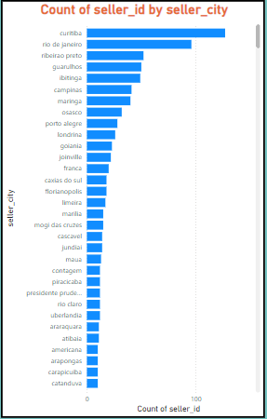

**Conclusion:** Understanding the distribution of sellers by city, while excluding cities starting with 'S' and 'B', provides valuable insights into regional business activity. Leveraging this information can help ShopNest make informed decisions about regional marketing strategies, operational focus, and market expansion.

Question 8: Create a dynamic visual that compares the number of delayed orders to the number of orders received earlier for each month. Utilize the drill through the cross-report feature to provide a detailed analysis of late and on-time deliveries.

Solution: I have created a new measure Month Column in the orders dataset based on the purchased_order_timestamp also I created measures to calculate the number of delayed orders and on-time orders.

This analysis compares the number of delayed orders to on-time orders on a monthly basis, providing insights into delivery performance. Drill-through functionality offers a detailed look at individual order metrics for further investigation

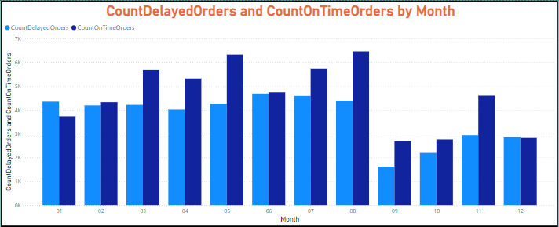

The chart gives the dynamic visual that compares the number of delayed orders to the number of orders received earlier for each month.

**Strategic Improvements:** Focus on months with higher delays to investigate potential causes, such as operational bottlenecks or supply chain issues. Implement strategies to improve delivery performance during these peak periods.

**Above are the analysis done based on Power Bi Dashboard and the hypothesis derived from it.**

**Thank you.**